Name: ……………………………………………….. ( ) Class: ……… Date: …………………..

|  |  |  |
| --- | --- | --- |
| **1.2** | **Data Representation** | **Number Systems** |

1. The following question is about denary conversion and the use of hexadecimal.
2. Convert the denary number 108 to an 8-bit binary number.

……………………………………………………………………………………………………………………………………………

……………………………………………………………………………………………………………………………………………

……………………………………………………………………………………………………………………………………………

……………………………………………………………………………………………………………………………………………

1. Convert the denary number 108 to hexadecimal.

……………………………………………………………………………………………………………………………………………

……………………………………………………………………………………………………………………………………………

……………………………………………………………………………………………………………………………………………

……………………………………………………………………………………………………………………………………………

1. Explain two common uses of the hexadecimal number system.

……………………………………………………………………………………………………………………………………………

……………………………………………………………………………………………………………………………………………

……………………………………………………………………………………………………………………………………………

……………………………………………………………………………………………………………………………………………

1. An elevator system in a building uses an 8-bit register. The first four bits indicate if any of the four sensors (i.e. display, lighting, motor and ventilator) has picked up a fault (as indicated by the value 1). The last four bits indicate the elevator number. There are 15 elevators in the building.

* 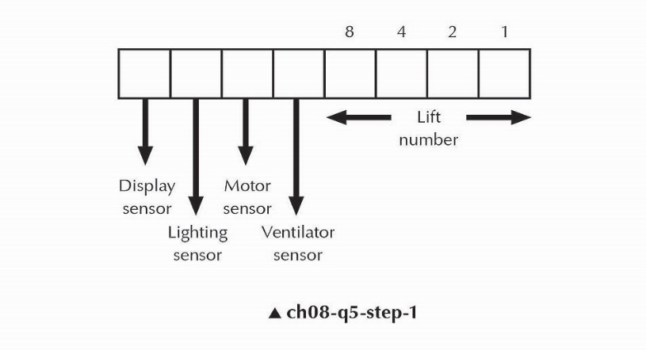
* For example,
* 
* indicates the following: there are faults in the lighting and motor subsystems for elevator number 3.

1. What is indicated when the register shows the following?
   * 

* …………………………………………………………………………………………………………………………………………
* …………………………………………………………………………………………………………………………………………

1. What is indicated when the register shows the following?
   * 

* …………………………………………………………………………………………………………………………………………
* …………………………………………………………………………………………………………………………………………

1. Work out the binary notation for faults in the display and lighting subsystems for elevator number 14.
   * 

* …………………………………………………………………………………………………………………………………………
* …………………………………………………………………………………………………………………………………………
* …………………………………………………………………………………………………………………………………………
* …………………………………………………………………………………………………………………………………………

1. In a factory, 127 electrical points provide power to various machineries. A 7-bit register is used to represent the state of each electrical point. The 8th bit is used to indicate if the state is operational or faulty. A value of 1 means the electrical point is operational and a value of 0 means the electrical point is faulty, which calls for attention.

* Thus, the following 8-bit register:
* 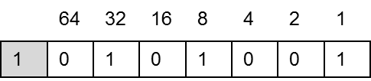
* means: electrical point number 41 is operational.

1. Interpret the reading if the register is showing:
   * 

* …………………………………………………………………………………………………………………………………………
* …………………………………………………………………………………………………………………………………………
* …………………………………………………………………………………………………………………………………………
* …………………………………………………………………………………………………………………………………………

1. Write down what the 8-bit register will show if electrical point number 36 is faulty.
   * 

* …………………………………………………………………………………………………………………………………………
* …………………………………………………………………………………………………………………………………………
* …………………………………………………………………………………………………………………………………………
* …………………………………………………………………………………………………………………………………………

1. If the reading on the 8-bit register was as below, what would it be in hexadecimal form?
   * 

…………………………………………………………………………………………………………………………………………

…………………………………………………………………………………………………………………………………………

…………………………………………………………………………………………………………………………………………

…………………………………………………………………………………………………………………………………………